EC-467 Mobile Application Development

BS (CE)-2021 LAB REPORT #8
Submitted By:

Reg. No. | Name
21-CE-009 | Huzaifa Shahbaz

Department of Computer Engineering
HITEC University Taxila
 | Presentation  (Format(0.5)+  Title (0.5)+  Conclusion(1)  +Procedure(2)  +Objective(1)) | Calculation/ Coding | Observation/  Program Results | Total
Total | 5 | 5 | 5 | 15
Obtained

Lab Instructor.
Dr. Muhammad Bilal

LAB REPORT #8
Fragments
Introduction: A Fragment is a piece of an activity which enable more modular activity design. A fragment is a kind of sub-activity. A Fragment represents a behavior or a portion of user interface in a Fragment Activity. Objectives of the experiment: 1.To get basic understanding regarding fragments. 2.To get basic understanding regarding how fragments pass information between fragments. 3.To get to know about the benefits related to Fragments. Tools: Android Studio Jellyfish
Class Task: Fragments JAVA CODE OF MAIN ACTIVITY:
package com.huzaifashahbaz.fragmentsapp;
import android.os.Bundle;
import android.view.View;
import android.widget.Button;
import androidx.appcompat.app.AppCompatActivity;
import androidx.fragment.app.Fragment;
import androidx.fragment.app.FragmentManager;
import androidx.fragment.app.FragmentTransaction;
public class MainActivity extends AppCompatActivity {
boolean isFragmentA=true;
FragmentManager fragmentManager;
FragmentTransaction fragmentTransaction;
FragmentA fragmentA;
FragmentB fragmentB;
String messageA="Message from Main for Fragment A";
String messageB="Message from Main for Fragment B";
Bundle args=new Bundle();
public static final String MSG_KEY="MSG_KEY";
@Override
protected void onCreate(Bundle savedInstanceState) {
super.onCreate(savedInstanceState);
setContentView(R.layout.activity_main);
fragmentA=new FragmentA();
fragmentB=new FragmentB();
replaceFragment(fragmentA,messageA);
Button replaceBtn=findViewById(R.id.replace_btn);
replaceBtn.setOnClickListener(new View.OnClickListener() {
@Override
public void onClick(View view) {
if (!isFragmentA)
{
replaceFragment(fragmentA,messageA);
isFragmentA=true;
}
else
{
replaceFragment(fragmentB,messageB);
isFragmentA=false;
}
}
});
}
void replaceFragment(Fragment fragment, String message)
{
args.putString(MSG_KEY,message);
fragment.setArguments(args);
fragmentManager=getSupportFragmentManager();
fragmentTransaction=fragmentManager.beginTransaction();
fragmentTransaction.replace(R.id.frame_container,fragment);
fragmentTransaction.addToBackStack(null);
fragmentTransaction.commit();
}
}
XML CODE OF MAIN ACTIVITY:
<?xml version="1.0" encoding="utf-8"?>
<LinearLayout
xmlns:android="http://schemas.android.com/apk/res/android"
xmlns:tools="http://schemas.android.com/tools"
android:orientation="vertical"
android:layout_width="match_parent"
android:layout_height="match_parent"
android:weightSum="4"
tools:context=".MainActivity">
<LinearLayout
android:orientation="vertical"
android:id="@+id/frame_container"
android:layout_weight="3"
android:layout_width="match_parent"
android:layout_height="match_parent">
</LinearLayout>
<Button
android:id="@+id/replace_btn"
android:layout_weight="1"
android:layout_gravity="center"
android:layout_width="wrap_content"
android:layout_height="wrap_content"
android:text="Replace" />
</LinearLayout>

JAVA CODE OF FRAGMENT-A:
package com.huzaifashahbaz.fragmentsapp;
import android.os.Bundle;
import android.view.LayoutInflater;
import android.view.View;
import android.view.ViewGroup;
import android.widget.TextView;
import androidx.annotation.NonNull;
import androidx.annotation.Nullable;
import androidx.fragment.app.Fragment;
public class FragmentA extends Fragment {
@Nullable
@Override
public View onCreateView(@NonNull LayoutInflater inflater, @Nullable ViewGroup container, @Nullable Bundle savedInstanceState)
{
View fragmentView=inflater.inflate(R.layout.fragment_a_layout,container,false);
TextView framentTV=fragmentView.findViewById(R.id.main_message_a);
if (getArguments()!=null)
{
String msg=getArguments().getString(MainActivity.MSG_KEY);
framentTV.setText(msg);
}
return fragmentView;
}
}
XML CODE OF FRAGMENT-A:
<?xml version="1.0" encoding="utf-8"?>
<LinearLayout xmlns:android="http://schemas.android.com/apk/res/android"
xmlns:app="http://schemas.android.com/apk/res-auto"
xmlns:tools="http://schemas.android.com/tools"
android:orientation="vertical"
android:padding="@dimen/view_margin"
android:background="@color/green"
android:layout_width="match_parent"
android:weightSum="10"
android:layout_height="match_parent">
<TextView
android:id="@+id/fragment_title_a"
android:gravity="center"
android:textSize="32sp"
android:textColor="@color/white"
android:layout_width="match_parent"
android:layout_height="0dp"
android:layout_weight="8"
android:text="Fragment A" />
<TextView
android:id="@+id/main_message_a"
android:gravity="center"
android:textColor="@color/white"
android:layout_width="match_parent"
android:layout_height="0dp"
android:layout_weight="2"
android:text="Message from main" />
</LinearLayout>
JAVA CODE OF FRAGMENT-B:
package com.huzaifashahbaz.fragmentsapp;
import android.os.Bundle;
import android.view.LayoutInflater;
import android.view.View;
import android.view.ViewGroup;
import android.widget.TextView;
import androidx.annotation.NonNull;
import androidx.annotation.Nullable;
import androidx.fragment.app.Fragment;
public class FragmentB extends Fragment {
@Nullable
@Override
public View onCreateView(@NonNull LayoutInflater inflater, @Nullable ViewGroup container, @Nullable Bundle savedInstanceState)
{
View fragmentView=inflater.inflate(R.id.fragment_b_layout,container,false);
TextView framentTV=fragmentView.findViewById(R.id.main_message_b);
if (getArguments()!=null)
{
String msg=getArguments().getString(MainActivity.MSG_KEY);
framentTV.setText(msg);
}
}
return fragmentView;
}
XML CODE OF FRAGMENT-B:
<?xml version="1.0" encoding="utf-8"?>
<LinearLayout xmlns:android="http://schemas.android.com/apk/res/android"
xmlns:tools="http://schemas.android.com/tools"
xmlns:app="http://schemas.android.com/apk/res-auto"
android:orientation="vertical"
android:padding="@dimen/view_margin"
android:background="@color/blue"
android:layout_width="match_parent"
android:weightSum="10"
android:layout_height="match_parent">
<TextView
android:id="@+id/fragment_title_a"
android:gravity="center"
android:textSize="32sp"
android:textColor="@color/white"
android:layout_width="match_parent"
android:layout_height="0dp"
android:layout_weight="8"
android:text="Fragment B" />
<TextView
android:id="@+id/main_message_b_tv"
android:gravity="center"
android:textColor="@color/white"
android:layout_width="match_parent"
android:layout_height="0dp"
android:layout_weight="2"
android:text="Message from main" />
</LinearLayout>
Results: 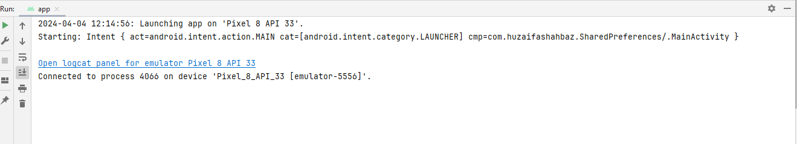
Output: 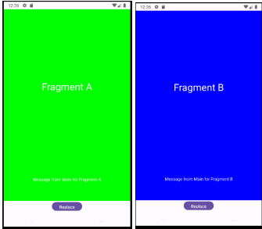
Home Task: Use Tasbeeh app and show history in separate fragment instead of separate activity. Note: Bundle can share string array list JAVA CODE OF MAIN ACTIVITY: package com.huzaifashahbaz.tabesshfragmentapp;
import android.os.Bundle;
import android.view.View;
import android.widget.Button;
import android.widget.TextView;
import android.widget.Toast;
import androidx.appcompat.app.AppCompatActivity;
import androidx.fragment.app.FragmentManager;
import androidx.fragment.app.FragmentTransaction;
import java.util.ArrayList;
public class MainActivity extends AppCompatActivity {
TextView tvCount;
Button btnCount, btnReset, btnViewHistory;
int Count = 0;
ArrayList<String> historyList = new ArrayList<>();
@Override
protected void onCreate(Bundle savedInstanceState) {
super.onCreate(savedInstanceState);
setContentView(R.layout.activity_main);
tvCount = findViewById(R.id.text_view_count);
btnCount = findViewById(R.id.btn_count);
btnReset = findViewById(R.id.btn_reset);
btnViewHistory = findViewById(R.id.btn_view_history);
btnCount.setOnClickListener(new View.OnClickListener() {
@Override
public void onClick(View v) {
onPressCountbtn(v);
}
});
btnReset.setOnClickListener(new View.OnClickListener() {
@Override
public void onClick(View v) {
onPressResetbtn(v);
}
});
btnViewHistory.setOnClickListener(new View.OnClickListener() {
@Override
public void onClick(View v) {
onPressHistorybtn(v);
}
});
}
public void onPressResetbtn(View view) {
Count = 0;
tvCount.setText("Count: " + Count);
historyList.clear();
}
public void onPressHistorybtn(View view) {
FragmentManager fragmentManager = getSupportFragmentManager();
FragmentTransaction fragmentTransaction = fragmentManager.beginTransaction();
HistoryFragment fragment = HistoryFragment.newInstance(historyList);
fragmentTransaction.replace(R.id.fragment_container, fragment);
fragmentTransaction.addToBackStack(null);
fragmentTransaction.commit();
}
public void onPressCountbtn(View view) {
Count++;
tvCount.setText("Count: " + Count);
historyList.add("Count: " + Count);
}
}
XML CODE OF MAIN ACTIVITY:
<?xml version="1.0" encoding="utf-8"?>
<LinearLayout xmlns:android="http://schemas.android.com/apk/res/android"
xmlns:tools="http://schemas.android.com/tools"
xmlns:app="http://schemas.android.com/apk/res-auto"
android:layout_width="match_parent"
android:layout_height="match_parent"
android:orientation="vertical"
android:padding="16dp">
<TextView
android:id="@+id/text_view_count"
android:layout_width="wrap_content"
android:layout_height="wrap_content"
android:text="Count: 0"
android:textSize="24sp" />
<Button
android:id="@+id/btn_count"
android:layout_width="wrap_content"
android:layout_height="wrap_content"
android:text="Count"
android:onClick="onPressCountbtn"/>
<Button
android:id="@+id/btn_reset"
android:layout_width="wrap_content"
android:layout_height="wrap_content"
android:text="Reset"
android:onClick="onPressResetbtn"/>
<Button
android:id="@+id/btn_view_history"
android:layout_width="wrap_content"
android:layout_height="wrap_content"
android:text="View History"
android:onClick="onPressHistorybtn"/>
<FrameLayout
android:id="@+id/fragment_container"
android:layout_width="match_parent"
android:layout_height="0dp"
android:layout_weight="1" />
</LinearLayout>
JAVA CODE OF History FRAGMENT:
package com.huzaifashahbaz.tabesshfragmentapp;
import android.os.Bundle;
import android.view.LayoutInflater;
import android.view.View;
import android.view.ViewGroup;
import android.widget.ArrayAdapter;
import android.widget.ListView;
import androidx.annotation.NonNull;
import androidx.annotation.Nullable;
import androidx.fragment.app.Fragment;
import java.util.ArrayList;
public class HistoryFragment extends Fragment {
private static final String ARG_HISTORY = "history";
private ArrayList<String> historyList;
public static HistoryFragment newInstance(ArrayList<String> history) {
HistoryFragment fragment = new HistoryFragment();
Bundle args = new Bundle();
args.putStringArrayList(ARG_HISTORY, history);
fragment.setArguments(args);
return fragment;
}
@Nullable
@Override
public View onCreateView(@NonNull LayoutInflater inflater, @Nullable ViewGroup container, @Nullable Bundle savedInstanceState) {
View view = inflater.inflate(R.layout.fragment_history, container, false);
ListView listView = view.findViewById(R.id.list_view_history);
if (getArguments() != null) {
historyList = getArguments().getStringArrayList(ARG_HISTORY);
}
if (historyList != null) {
ArrayAdapter<String> adapter = new ArrayAdapter<>(getContext(), android.R.layout.simple_list_item_1, historyList);
listView.setAdapter(adapter);
}
return view;
}
}
XML CODE OF History FRAGMENT:
<?xml version="1.0" encoding="utf-8"?>
<LinearLayout xmlns:android="http://schemas.android.com/apk/res/android"
xmlns:app="http://schemas.android.com/apk/res-auto"
xmlns:tools="http://schemas.android.com/tools"
android:layout_width="match_parent"
android:layout_height="match_parent"
android:orientation="vertical">
<ListView
android:id="@+id/list_view_history"
android:layout_width="match_parent"
android:layout_height="match_parent" />
</LinearLayout>
Results: 
Output:
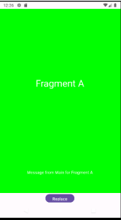
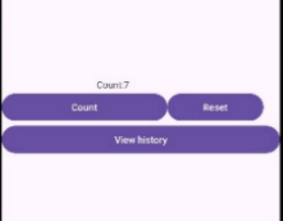
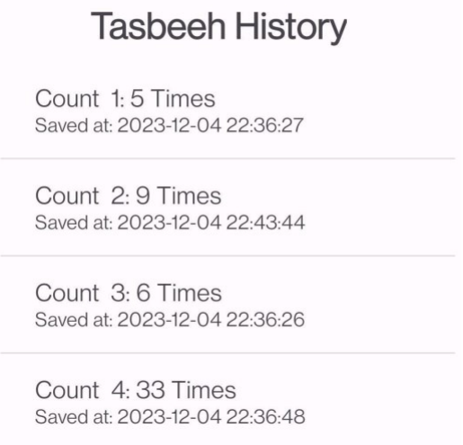
Conclusion: In conclusion we had learn how to make fragments app and also tabseeh fragment app by using history fragment in tasbeeh main activity.

